History 389: Food in Modern America

GEP Historical Perspectives  Course Meetings: 12:00-12:50 MWF  Office Hours: 1:00-2:00 TR | UWSP – History Department  Dr. Neil Prendergast  nprender@uwsp.edu | UWSP – History Department  Dr. Neil Prendergast  nprender@uwsp.edu

Recently, Americans of all sorts have been arguing—quite passionately—about their food. Is it best to shop for organic food? Are ‘paleo’ foods really better for us? Is gluten bad? A generation ago, similar headlines filled the newspapers: How much fiber should I eat? Do eggs increase cholesterol? Is butter better than margarine? Yet another generation earlier still more questions were common: Are my kids getting enough vitamins? Will grocery store cranberries make me sick? Is the milk safe from strontium? And we could go back even further: What’s a vitamin? Is the butter pure? Is the meat safe?

In short, Americans have long been insecure about their food, at least since they stopped raising it themselves and started buying it from stores. Certainly the questions we ask today could be readily answered by nutritionists and other health care professionals. But all those questions from previous generations suggests something else is going on. There is a tradition of anxiety and insecurity. Why?

The answer to that question must be historical. “Food in Modern America” will help you see that uncertainty about food is more than individual; it is a product of changes in science, business, government, and culture.

Each of the questions above asks about food, but also underscores larger concerns about modern life. Is there strontium in the milk? That’s a question about whether the government would protect citizens from radioactive fallout during the Cold War. Is the meat safe? That’s a question about whether some of the first large corporations in America—meatpacking companies—could be trusted.

In other words, studying the history of food can help you understand a great deal about the complexity of modern America. We will examine the place of science in society, the role of business in framing consumer choices, the presence of government in American life, and the power of culture to ascribe meaning to the material world.

This way of thinking about food might be brand new for you. As you can see, I think it’s a useful way to expand our thinking—and I’m incredibly excited to share this perspective with you. If you’re entering a wellness or healthcare profession, then this course will certainly help you think about your career ahead. If you’re entering another field—or just interested in food—then this course will still be useful, perhaps by sparking a new interest in the past.

 |  | Enduring Understanding:  Culture, science, and business set the frame for an individual’s choices about food.  Learning Outcomes: After taking this course, students will be able to:  - Use primary sources to answer questions about how foodways have changed in American history  - Describe differences among interpretations of American food history  - Analyze how changes in science, culture, and corporations have affected American foodways |  | 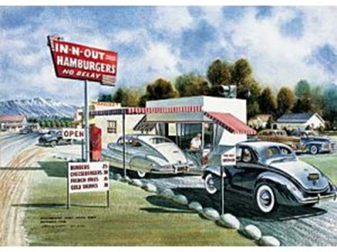
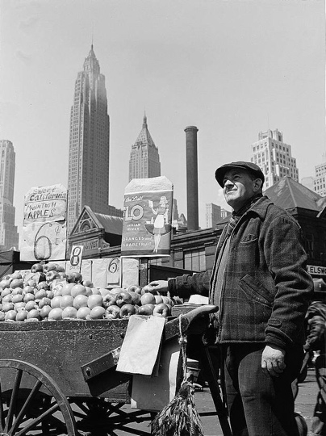 |  |  | Dr. Prendergast’s Office Hours: 473 Collins Classroom Center TR 1:00-2:00pm You are welcome to visit me in my office. I set aside office hours so that I have the chance to talk with students one-on-one. During that time, my only commitment is to speak with my students.  Email: nprender@uwsp.edu In addition to office hours, email is a great way to get a hold of me.  (If you’re uncertain about how to write an email to a professor, then this is a great template: https://medium.com/@lportwoodstacer/how-to-email-your-professor-without-being-annoying-af-cf64ae0e4087 )
Course Materials
Required Books (Available Online via the University Library):

Helen Zoe Veit, Modern Food, Moral Food: Self-Control, Science, and the Rise of Modern American Eating in the Early Twentieth Century (Chapel Hill: University of North Carolina Press, 2015).

Tracey Deutsch, Building a Housewife’s Paradise: Gender, Politics, and American Grocery Stores in the Twentieth Century (Chapel Hill: University of North Carolina Press, 2012).

Warren Belasco, Appetite for Change: How the Counterculture Took on the Food Industry, 2nd Updated Ed. (Ithaca: Cornell University Press, 2007).

Canvas: You will also need access to the university’s learning management system, Canvas.

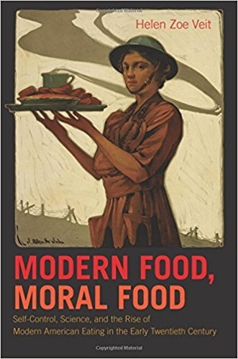 |  |  | 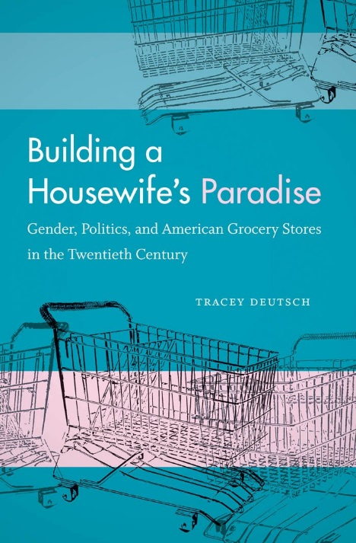 |  |  | 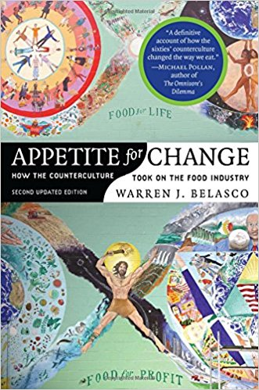

Grading:

40 points for Regular Work [20 @ 2 each]
30 points for Unit Papers [3@ 10 each]
30 points for Final Paper
100 points total

Letter grades for the semester follow the typical pattern:

A 93-100 | B+ 87-89.99 | C+ 77-79.99 | D+ 67-69.99 | F 59.99 and below
A- 90-92.99 | B 83-86.99 | C 73-76.99 | D 60-66.99
 | B- 80-82.99 | C- 70-72.99

Life Happens: I understand that life might make it difficult to complete some assignments, attend class, or simply to do well. I also know that some real learning has to take place in this class. You will have more opportunities in life if you can analyze, think critically and communicate effectively. This class has to be one of your priorities. I do my best to be flexible, but need to adhere to some standards. So, if something comes up, let’s talk. | 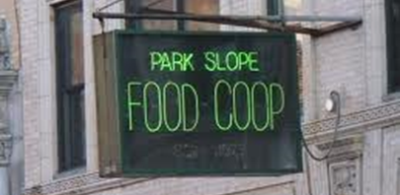
Course Policies: During the class, cell phones and other electronic devices are prohibited. If you are a parent or are otherwise obligated to be available to your family via cell phone, then please discuss that situation with me, so I know that you have a good reason for keeping your phone turned on.

The prohibition of electronics also extends to laptop computers (unless approved by the Disability Services Office). While laptops are great aides in studying, the class is diminished when everyone’s attention is scattered. The focus in class is on class, not the computer screen. Further, the ability to take notes longhand is actually an important skill to develop, one that will be useful in any career you choose.

For information on plagiarism, consult http://www.uwsp.edu/centers/rights. See Chapter 14, Student Academic Standards and Disciplinary Procedures, pages 5 -10, for the disciplinary possibilities if you are caught cheating. As an instructor deeply concerned with fairness in the classroom, we pursue each and every case of plagiarism and cheating. Please note that turnitin.com is used for the essay assignments.

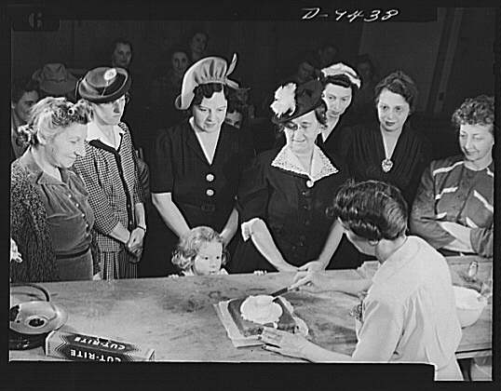 |  | Discussion Actively listening to each other, asking thoughtful questions of each other, and offering basic respect are important parts of intellectual exchanges. But being prepared in all the normal ways is also an important part of discussion. Showing up to class with the readings finished, taking notes, and creating your own questions and opinions are all individual efforts that show others you care and that they should care, too.  (The unfortunate flip side is that when you show up unprepared, the prepared students feel as though they’ve wasted their time. They start to prepare less and the bar in the class lowers and lowers until class meetings are just not challenging, fun, or interesting anymore.)
Equity of Educational Access: If you have a learning or physical challenge which requires classroom accommodation, please contact the UWSP Disability Services office with your documentation as early as possible in the semester. They will then notify me, in a confidential memo, of the accommodations that will facilitate your success in the course. Disability Services Office, 103 Student Services Center, Voice: (715) 346-3365, TTY: (715) 346-3362, http://www.uwsp.edu/special/disability/studentinfo.htm.

Note: The syllabus is a general plan for the course. Deviations announced in class may be necessary.

Course Contacts:
Name | Email

A Note on Reading: A look at the schedule will show that two or three chapters—or about fifty or sixty pages—of reading is common in most weeks. That pushes the upper limit of what I expect from students. In practice, however, the reading load is not exactly that length. At the end of each class period, I will assign a question to be answered from a portion of the reading. I’ll even provide a narrowed page range to look for the answer. In the end, the actual reading required of students will be much lower than the fifty or sixty pages—more like twenty or thirty per week.
Schedule
Why the History of Food Matters
Week 1 |  | Wednesday Introduction | Friday Introduction  “Food: Key Concepts” Canvas
How did modern science transform American eating?
Week 2 | Monday Lecture  “Problems of Plenty” Canvas | Wednesday Book Discussion  “Introduction” and “Ch. 1: Victory over Ourselves,” Modern Food, Moral Food | Friday Book Discussion  “Ch. 2: The Progressive Quest for Rational Food,” Modern Food, Moral Food
Week 3 | Monday Book Discussion  “Ch. 3: Food Aid and American Power,” Modern Food, Moral Food | Wednesday Book Discussion  “Ch. 4: Home Economics and the Modern Housewife,” Modern Food, Moral Food | Friday Book Discussion  “Ch. 5: Race, Diet, and the Eugenics of Nutrition,” Modern Food, Moral Food
Week 4 | Monday Book Discussion  “Ch 6: Americanizing the American Diet,” Modern Food, Moral Food | Wednesday Document Discussion  “America Eats,” Library of Congress Manuscript, Canvas | Friday Book Discussion  “Ch. 7: The Progressive Body and the Thin Ideal,” Modern Food, Moral Food
Week 5 | Monday Film Discussion  “Vitamins from Food,” Dairy Council of California, Canvas | Wednesday  UNIT ONE COMPLETE DRAFT DUE | Friday UNIT ONE FINISHED DRAFT DUE
How did changes in business, especially retail, influence the American diet?
Week 6 | Monday Document Discussion  “DeVoe’s Market Book” in class document | Wednesda Book Discussion  “Ch. 1: Women and the Social Politics of Food Procurement,” Building a Housewife’s Paradise | Friday Book Discussion  “Ch. 2: The Rise of Chain Grocery Stores, Building a Housewife’s Paradise
Week 7 | Monda Document Discussion  “Selected Articles from Progressive Grocer,” Canvas | Wednesday Book Discussion  “Ch. 4: Consumer Movement and Consumer Cooperatives,” and “Ch. 3: Changing Politics of Mass Consumption,” Building a Housewife’s Paradise | Friday Book Discussion  “Ch. 5: Politics of Supermarkets,” Building a Housewife’s Paradise
Week 8 | Monday Book Discussion  “Ch. 6: Gender and Grocery Stores,” Building a Housewife’s Paradise | Wednesday Document Discussion  “Giant Food Stores Advertisements,” Prelinger Collection, Duke University Canvas | Friday Book Discussion  “Ch. 7: Politics of Postwar Mass Retail,” Building a Housewife’s Paradise
Week 9 | Monday Film Discussion  “Supermarkets Inc.” Canvas | Wednesday  UNIT TWO COMPLETE DRAFT DUE | Friday UNIT TWO FINISHED DRAFT PAPER
What potential does cultural change have for transforming American foodways?
Week 10 | Monday Lecture  “The Counterculture in America” | Wednesday Book Discussion  “Ch. 1: An Edible Dynamic, Appetite for Change | Friday Book Discussion  “Ch. 2: Radical Consumerism,” Appetite for Change
Week 11 | Monday Book Discussion  “Ch. 4: An Alternative Infrastructure,” Appetite for Change | Wednesday Film Discussion  “Food Coop,” Canvas | Friday Document Discuss.  “Willy Street Coop,” Wisconsin Historical Society Canvas
Week 12 | Monday Book Discussion  “Ch. 5: The Orthodox Defense,” Appetite for Change | Wednesday  TBA | THANKSGIVING BREAK
Week 13 | Monday Book Discussion  “Ch. 6: The Mess in Washington,” Appetite for Change | Wednesday Book Discussion  “Ch. 7: The Press: Shifting the Center,” Appetite for Change | Friday Book Discussion  “Ch. 10: A Healthy Foods Portfolio,” Appetite for Change
Week 14 | Monday  UNIT THREE COMPLETE DRAFT DUE | Wednesday  UNIT THREE FINISHED DRAFT DUE | Friday Final Paper Introduction
Week 15 | Monday Paper Workshop | Wednesday Paper Workshop | Friday Paper Workshop
Final Exam Week | FINAL PAPER DUE at final exam period, Monday, December 16th at 10:15am

NOTES: (1) On rare occasions, we will replace our in-class meeting with an online one. Such replacements will be announced via Canvas and email. This policy is mostly for inclement weather and unexpected circumstances. (2) The syllabus is a plan for the course, which means dates may be adjusted as the semester progresses—although I try very hard not to let that happen. Any changes will be announced via Canvas and email.

